DATA FLOW DIAGRAM TEMPLATE

Online Ride Sharing

Prepared by Abdul Rehman Aamir

Bcs163001

Capital University of Science and Technology

May 4th, 2018

**REVISION HISTORY**

|  |  |  |
| --- | --- | --- |
| **Date** | **Description** | **Author** |
| 4/5/2018 | Online Ride Sharing | Abdul Rehman Aamir |

Contents

**1 Introduction** 8

**1.1** **About Project:** 8

**1.2** **Purpose:** 8

**1.3** **Scope:** 8

**1.4** **Modules:** 8

**1.5 Conclusion** 8

**2** **Steps for Data Flow Diagram** 8

**2.1** **Listing all Use Cases** 8

3 Selecting Use Case 10

Admin Login 10

3.1 Assigning Name to Use Case 10

Login Admin. 10

Main Steps: 10

3.2 Defining Conditions According to Situation 10

3.3 Identifying Entities 10

3.4 Identifying Data Flow 10

3.5 Identifying data store 10

3.6 Identify Data 10

3.7 Context Level Diagram: 11

3.8 Level 0 Diagram: 12

3.9 Level 1 Diagram 13

4 Selecting Use Case 14

Student Can Generate Challan 14

4.1 Assigning Name to Use Case 14

Generating challan 14

Main Steps: 14

4.2 Defining Conditions According to Situation 14

4.3 Identifying Entities 14

• Student 14

4.4 Identifying Data Flow 14

Login account to data base 14

4.5 Identifying data store 14

Database 14

4.6 Identify Data 14

Student Information 14

4.7 Context Level Diagram 15

4.8 Level 0 Diagram 15

15

4.9 Level 1 Diagram 15

15

5 Selecting Use Case 16

Student Can Generate Pass 16

5.1 Assigning Name to Use Case 16

Generating Pass 16

Main Steps: 16

5.2 Defining Conditions According to Situation 16

5.3 Identifying Entities 16

• Student 16

5.4 Identifying Data Flow 16

1.6 Login account to data base 16

5.5 Identifying data store 16

Database 16

5.6 Identify Data 16

Student Information 16

5.7 Level 0 Diagram 17

5.8 Level 0 Diagram 17

17

5.9 Level 1 Diagram 17

17

5.10 Level 1 Diagram 18

6 Selecting Use Case 19

Student Can login 19

6.1 Assigning Name to Use Case 19

Login student 19

Main Steps: 19

6.2 Defining Conditions According to Situation 19

6.3 Identifying Entities 19

• Student 19

6.4 Identifying Data Flow 19

1.7 Login account to data base 19

6.5 Identifying data store 19

Database 19

6.6 Identify Data 19

Admin Information 19

6.7 Context Level Diagram: 20

6.8 Level 0 Diagram: 20

6.9 Level 1 Diagram 20

7 Selecting Use Case 21

Student Can Cancel Rides 21

7.1 Assigning Name to Use Case 21

Cancel Rides 21

Main Steps: 21

7.2 Defining Conditions According to Situation 21

7.3 Identifying Entities 21

• Student 21

7.4 Identifying Data Flow 21

1.8 Login account to data base 21

7.5 Identifying data store 21

Database 21

7.6 Identify Data 21

Admin Information 21

7.7 Context Level Diagram: 22

7.8 Level 0 Diagram 22

7.9 Level 1 Diagram 23

8 Selecting Use Case 24

Driver Can Signup 24

8.1 Assigning Name to Use Case 24

Signup Driver 24

Main Steps: 24

8.2 Defining Conditions According to Situation 24

8.3 Identifying Entities 24

• Driver 24

8.4 Identifying Data Flow 24

1.9 Login account to data base 24

8.5 Identifying data store 24

Database 24

8.6 Identify Data 24

Admin Information 24

8.7 Context Level Diagram 25

8.8 Level 0 Diagram 25

8.9 Level 1 Diagram 26

# **1 Introduction**

## **About Project:**

The aim of this project is to design an application for the cust bus system so that students can easily get registered online. Admin can track every bus related to cust bus system and students can take multiple actions against bus. It would be easy for admin, driver and the student to coordinate.

## **Purpose:**

A **Data Flow Diagram** is an excellent tool to understand the flow of the data. Through DFD we can identify the entities, stores etc.

## **Scope:**

The scope for the system can be as follows:

* Online registration of students
* Keep a track on buses.
* Feature to cancel ride anytime

## **Modules:**

The main users in the project can be categorized into three modules.

* Admin
* Driver
* Student

## **1.5 Conclusion**

After Studying the whole feasibility report it is concluded that this application is useful and economical and will provide a good usability to the user.

# 

# **Steps for Data Flow Diagram**

## **Listing all Use Cases**

* Admin Login
* Student Login
* Driver Login
* Student Signup
* Driver Signup
* Admin Signup
* Generate Pass
* Generate Challan Form
* Student Cancel Ride
* Bus Monitoring

### Selecting Use Case

### Admin Login

## Assigning Name to Use Case

### Login Admin.

## Main Steps:

1. Enter User Name and Verify User Name
2. Enter Password and Verify Password
3. Enter Captcha and Verify Captcha

## Defining Conditions According to Situation

1. Admin have to enter username correctly otherwise an error message will occur
2. Admin have to enter password correctly otherwise an error message will occur
3. Admin have to enter captcha correctly otherwise an error message will occur
4. If he entered all the fields correctly then show the next page.

## 3.3 Identifying Entities

* Admin

## Identifying Data Flow

* Admin to login account
* Login account to data base

## 3.5 Identifying data store

* Database

## Identify Data

* Admin Information

# Context Level Diagram:

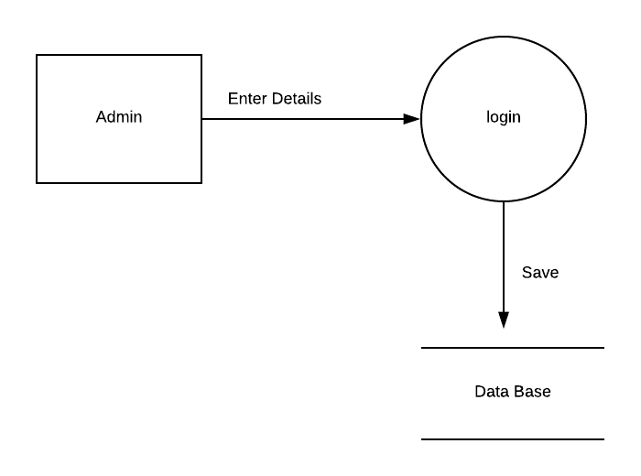

## Level 0 Diagram:

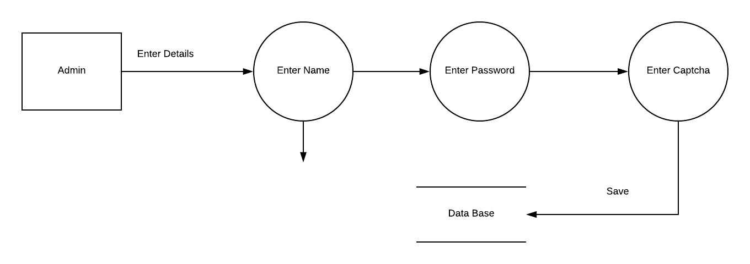

## Level 1 Diagram

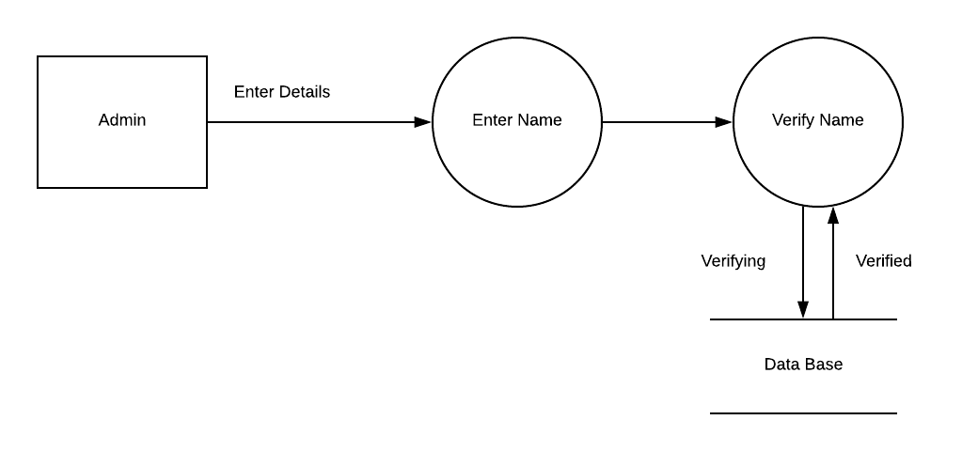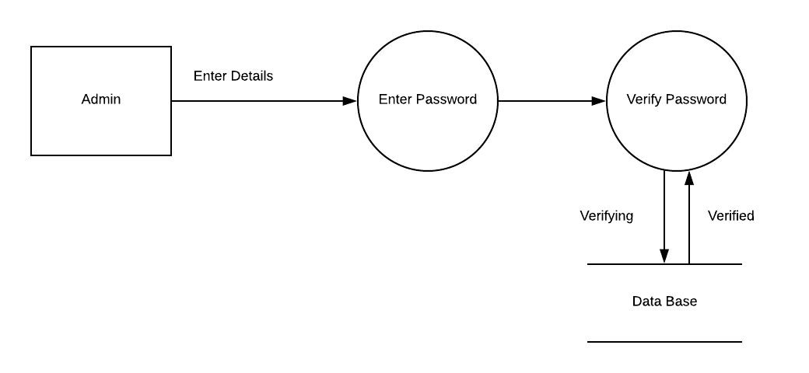

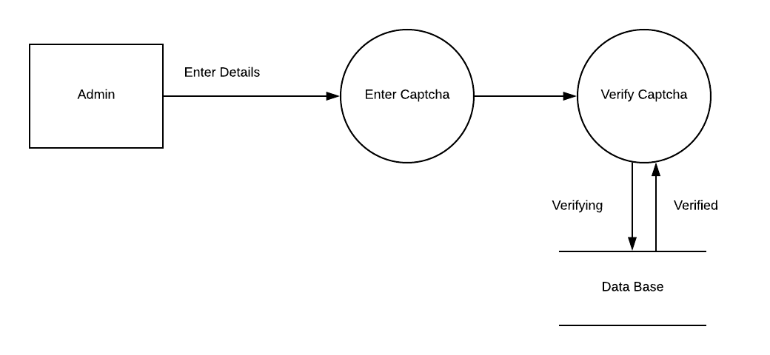

### Selecting Use Case

### Student Can Generate Challan

## Assigning Name to Use Case

### Generating challan

## Main Steps:

1. Login to the Account
2. Ask for challan

## Defining Conditions According to Situation

1. Student have to login to the valid account
2. Student have to ask for challan
3. Product will verify the details and prints it

## Identifying Entities

## Student

## Identifying Data Flow

## Login account to data base

## Identifying data store

## Database

## Identify Data

## Student Information

## Context Level Diagram

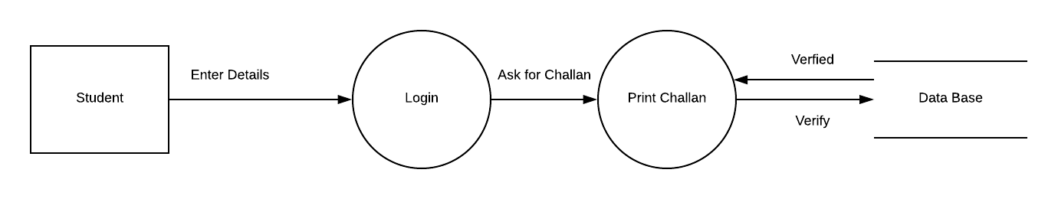

## Level 0 Diagram

## 

## Level 1 Diagram

## 

### Selecting Use Case

### Student Can Generate Pass

## Assigning Name to Use Case

### Generating Pass

## Main Steps:

1. Login to the Account
2. Enter the valid number of paid challan form
3. Ask for pass

## Defining Conditions According to Situation

1. Student have to enter username correctly otherwise an error message will occur
2. Student have to enter password correctly otherwise an error message will occur
3. Student have to enter captcha correctly otherwise an error message will occur
4. If he entered all the fields correctly then show the next page.

## Identifying Entities

## Student

## Identifying Data Flow

## Login account to data base

## Identifying data store

## Database

## Identify Data

## Student Information

## Level 0 Diagram

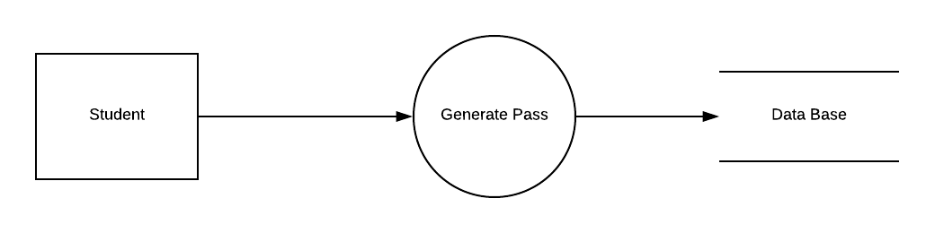

## Level 0 Diagram

## 

## Level 1 Diagram

## 

## Level 1 Diagram

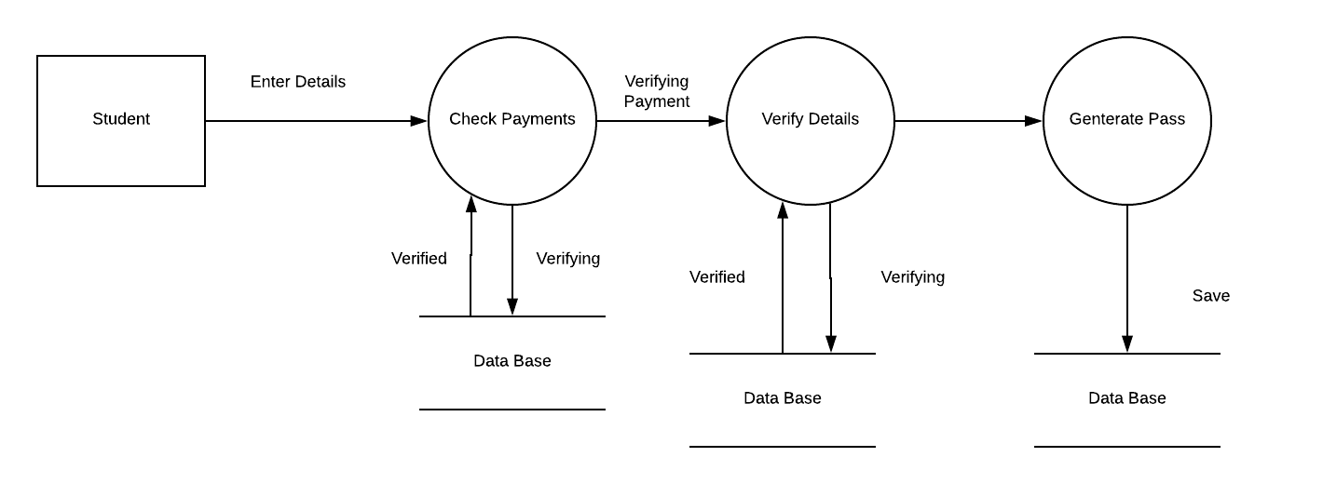

### Selecting Use Case

### Student Can login

## Assigning Name to Use Case

### Login student

## Main Steps:

1. Enter User Name and Verify User Name
2. Enter Password and Verify Password
3. Enter Captcha and Verify Captcha

## Defining Conditions According to Situation

1. Student have to enter username correctly otherwise an error message will occur
2. Student have to enter password correctly otherwise an error message will occur
3. Student have to enter captcha correctly otherwise an error message will occur
4. If he entered all the fields correctly then show the next page.

## Identifying Entities

## Student

## Identifying Data Flow

## Login account to data base

## Identifying data store

## Database

## Identify Data

## Admin Information

## Context Level Diagram:

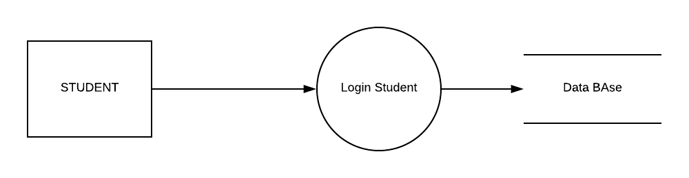

## Level 0 Diagram:

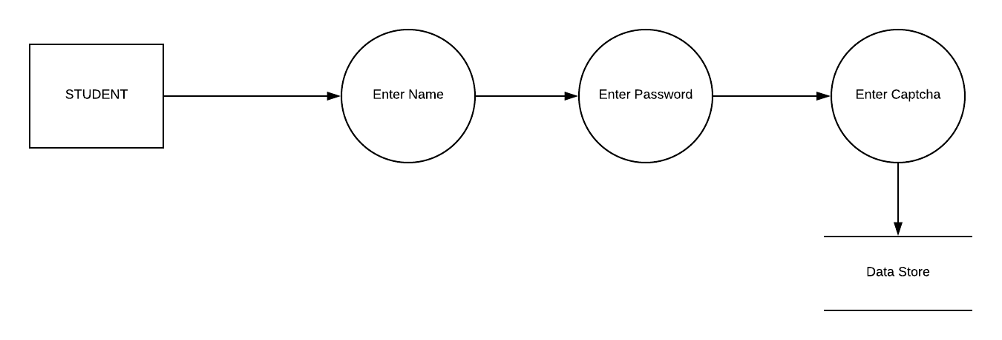

## Level 1 Diagram

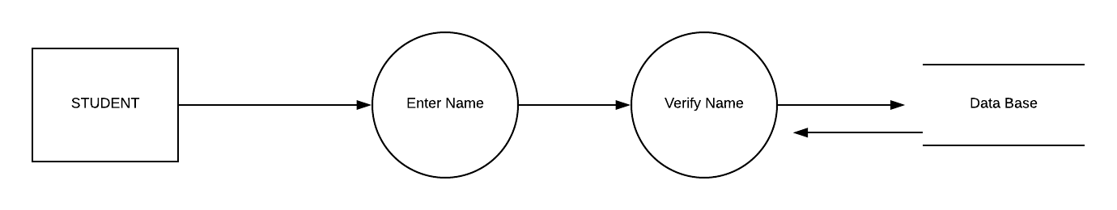

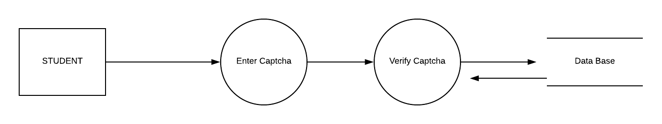

### Selecting Use Case

### Student Can Cancel Rides

## Assigning Name to Use Case

### Cancel Rides

## Main Steps:

1. Login to the account
2. Enter the bus number
3. Ask for ride cancelling

## Defining Conditions According to Situation

1. Student have to enter username correctly otherwise an error message will occur
2. Student have to enter password correctly otherwise an error message will occur
3. Student have to enter captcha correctly otherwise an error message will occur
4. If he entered all the fields correctly then show the next page.

## Identifying Entities

## Student

## Identifying Data Flow

## Login account to data base

## Identifying data store

## Database

## Identify Data

## Admin Information

## Context Level Diagram:

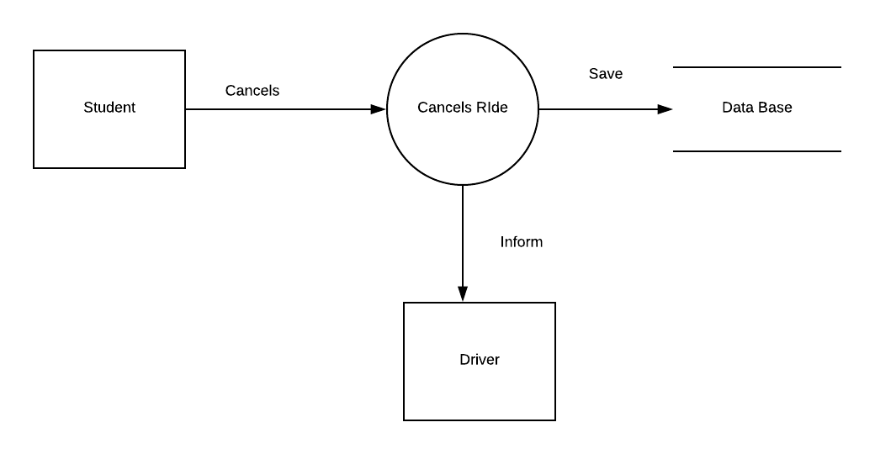

## Level 0 Diagram

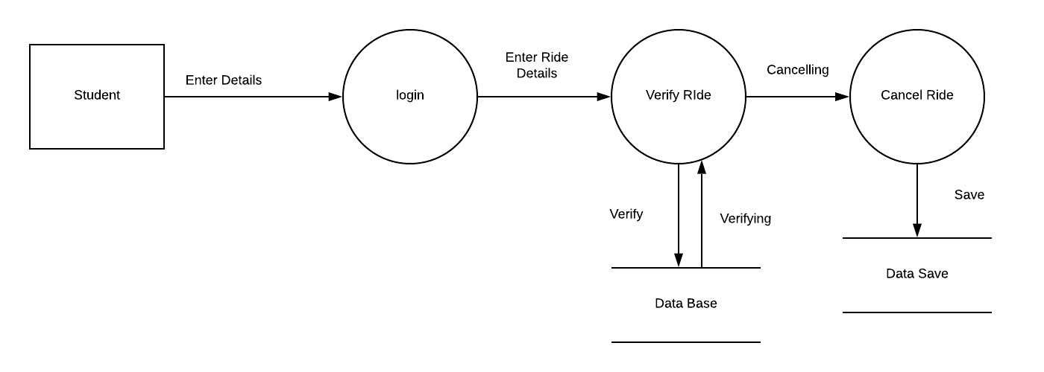

## Level 1 Diagram

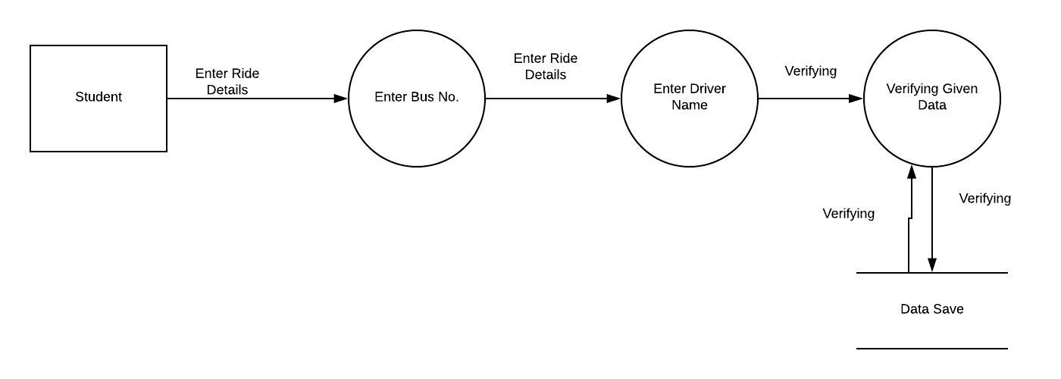

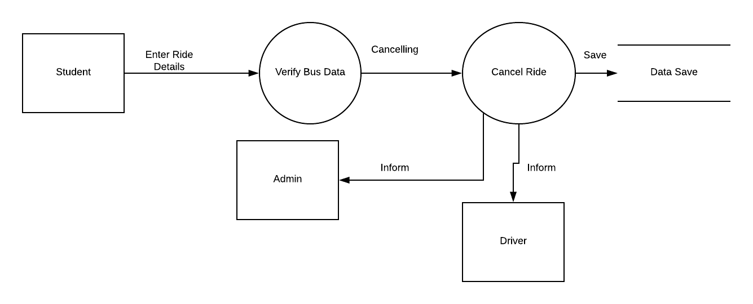

### Selecting Use Case

### Driver Can Signup

## Assigning Name to Use Case

### Signup Driver

## Main Steps:

1. Enter User Name and Verify User Name
2. Enter Password and Verify Password
3. Enter Captcha and Verify Captcha

## Defining Conditions According to Situation

1. Driver have to enter username correctly otherwise an error message will occur
2. Driver have to enter password correctly otherwise an error message will occur
3. Driver have to enter captcha correctly otherwise an error message will occur
4. If he entered all the fields correctly then show the next page.

## Identifying Entities

## Driver

## Identifying Data Flow

## Login account to data base

## Identifying data store

## Database

## Identify Data

## Admin Information

## Context Level Diagram

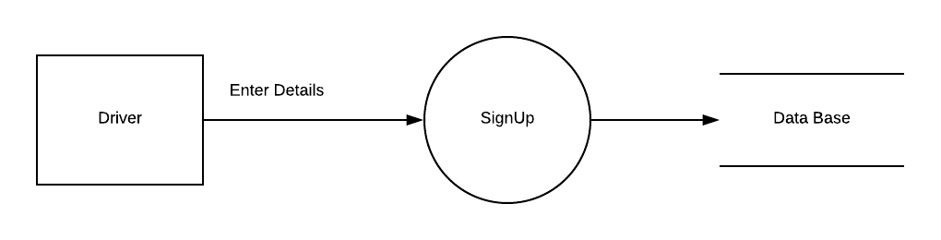

## Level 0 Diagram

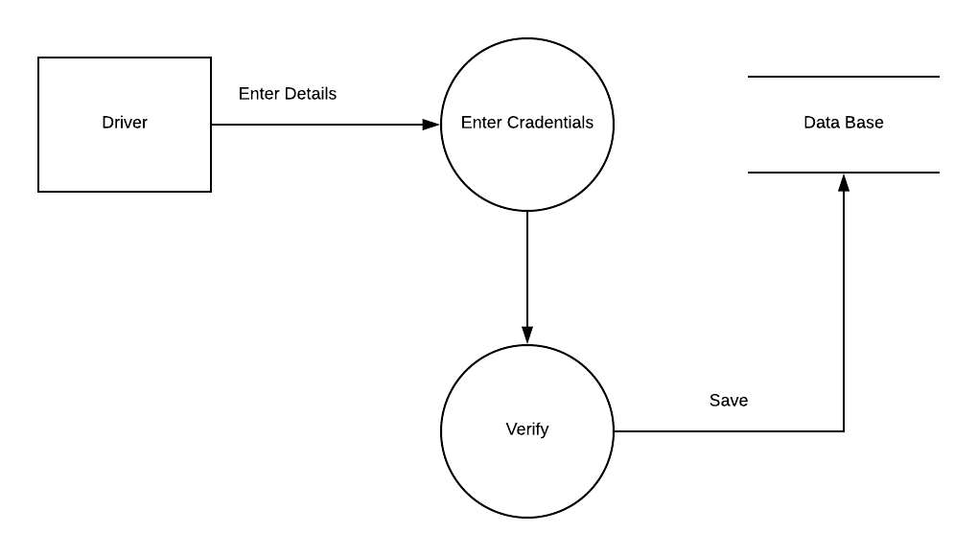

## Level 1 Diagram

